**Screenshot Successful GET and POST Requests**

**Successful GET Request:**

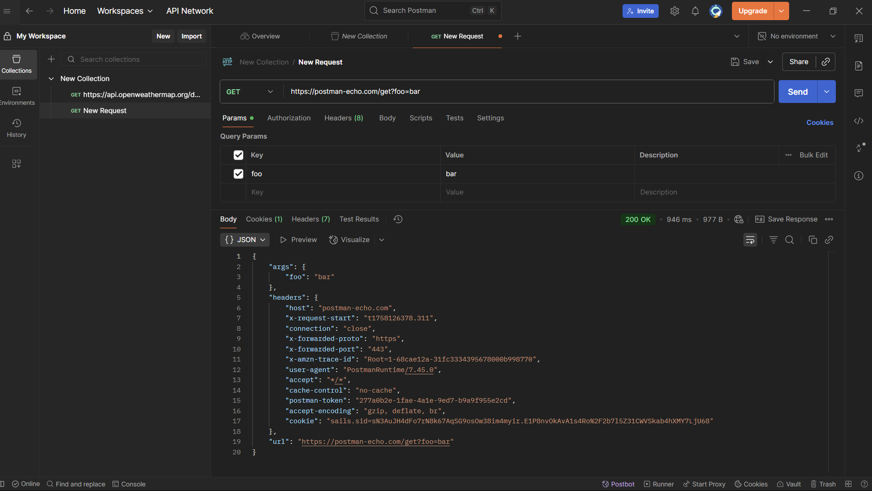

**Successful POST Request:**

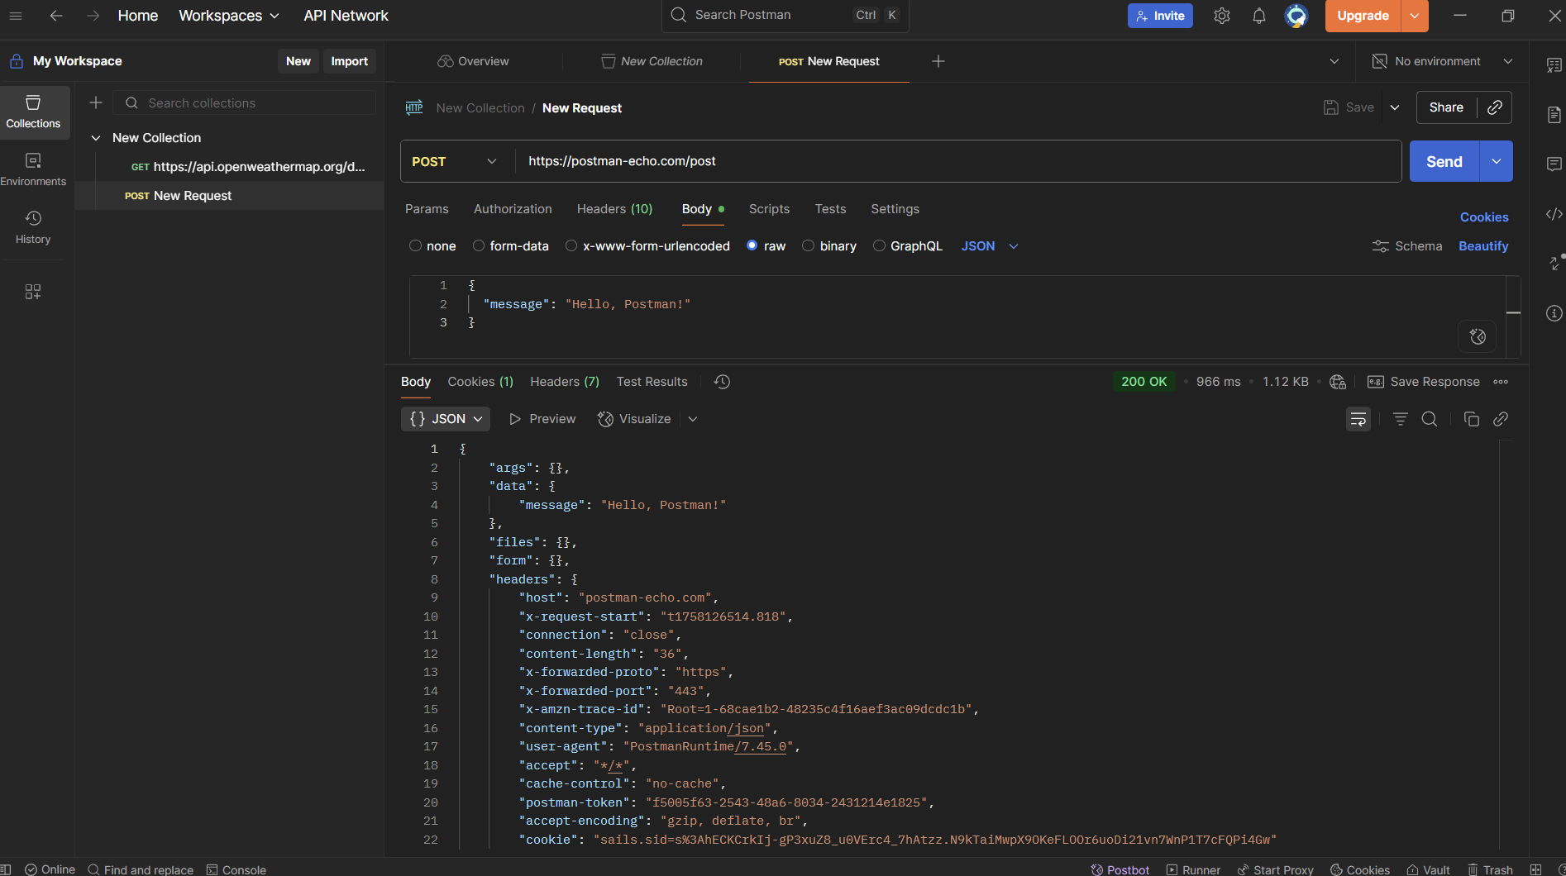

**GET Request to PokéAPI and Screenshot the JSON**

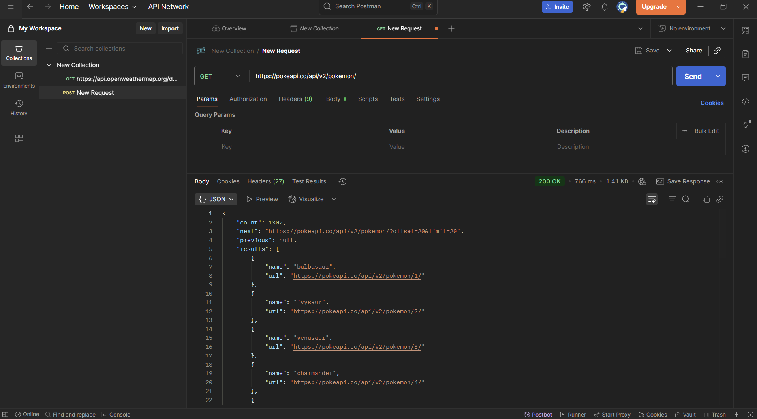

**With custom name to the base url**

